Study abroad credit & academic records

# Residence credit defined:

**The only study abroad credit that counts toward residency requirements is CSU IP. All other study abroad credit is transfer credit, so keep the residency requirements in mind.**

For both the BA & BS degrees, students must earn a minimum of **30** semester units in regular course at Humboldt. Of those 30 units, **24** must be upper division with *at least* **12** of the upper division units in the major. All students must earn at least **9** units of general education coursework at Humboldt.

# Returning to HSU

Once your official transcripts arrive at HSU, it can take 2-4 weeks for us to process these and add that information to your DARS. Once updated, carefully review your DARS to confirm that everything looks as you expect.

# Study Abroad Transfer Credit Agreement

If courses were approved before departure on your Study Abroad Transfer Credit Agreement, or if courses are later approved via a major contract or petition, those courses will show up throughout DARS to meet any applicable requirements.

**If you notice that a study abroad course does not show up in DARS where you expect to see it, this means the course is not meeting the requirement for graduation. Students should take action ASAP by contacting the Office of the Registrar to inquire about the next steps to resolve the issue.**

Examples on the following pages will show how your study abroad credit will appear on both DARS and your official HSU Transcript.

# Bilateral Exchange

All work is considered TRANSFER credit (i.e., non-resident) and counts toward OVERALL GPA.

## Bilateral Exchange DARS

To review your transfer credit, go to the end of the audit: **Academic Record > Transfer Work.** Note that *below* the course title you will see an abbreviation of the school name (AU JCOOK for Australia: James Cook U), followed by the actual course code “MB 3191” at the university.

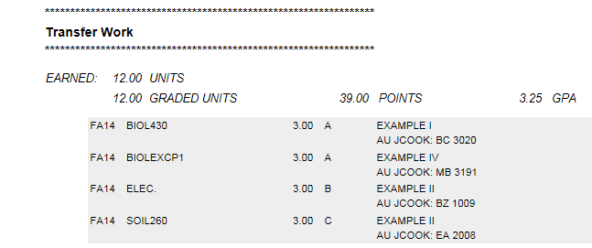

**How exactly did my courses transfer?** All of these courses will also show up throughout DARS to meet GE, All-University and/or major requirements they are approved for. On the left side you will see any HSU equivalencies, as circled below. If you see a specific HSU course like BIOL 430 this means future pre-requisites will be met with study abroad credit. Otherwise, you might see “ELEC.” for elective credit, a GE code, or if you had a course approved on a major contract you might see an exception code here, such as “BIOLEXCP1” below.

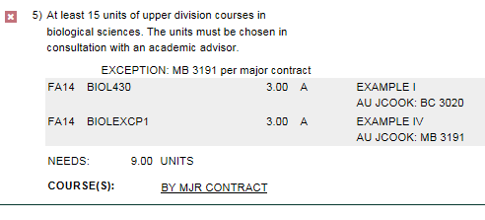

## Bilateral Exchange on HSU transcripts

Review unofficial transcripts via Student Center. Credit appears at the **top left** under **Transfer Credits**:

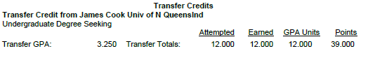

# Third Party

The process is very similar to bilateral exchange—in fact if your program provides an *official transcript* from the university you attended, it will appear exactly same as bilateral exchange above, **see above.**

However if we do not receive an official transcript from the institution attended, but instead receive a grade report (like from USAC or CIEE), the transfer credit will post as coming from the general provider rather than the specific institution attended.

**On DARS, if an official transcript not received you’ll see something like “TP_USAC” (3rd Party: USAC):**

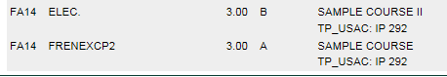

Review unofficial transcripts via Student Center. Credit appears at the **top left** under **Transfer Credits**:

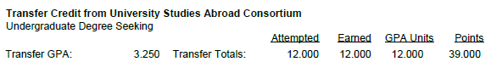

# CSU IP

All work is considered **residence credit** and will be reflected on HSU transcripts in the term the courses were taken, counts toward HSU GPA & OVERALL GPA.

**In DARS, CSU IP coursework will show under Humboldt State coursework. Any substitutions will be noted throughout your DARS where appropriate:**

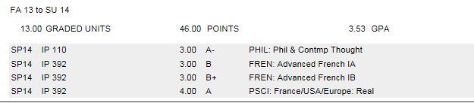

**On the HSU Transcript, CSU IP appears in the term the coursework was taken and contributes to HSU units and HSU GPA:**

